Mech 12 Computational Project #1b, Fall 2015
(Due September 9, 2015)

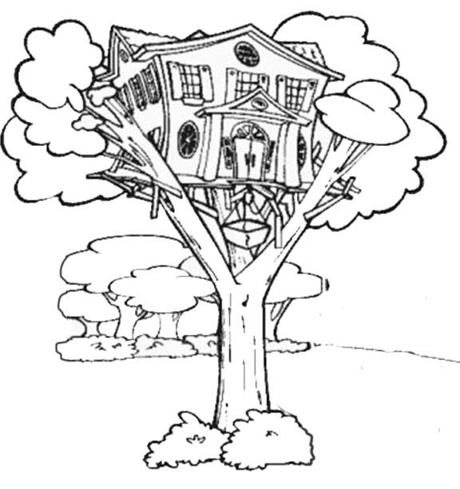
This next part of the project is a team-based activity. You must hold at least one face-to-face meeting prior to submitting your team response and your team submission must include minutes from the meeting; additional team interaction may occur via electronic means or face-to-face meetings as needed. Note that meeting minutes do not count in word count limits described below but minutes themselves should be 100-150 words. Meeting minutes should be a team writing effort.

Use your individual lists of trunk design metrics as well as discussion from lecture to assemble your team’s formal response. Again, the response you are formulating is to the approximate question, “What are the most salient design metrics for the tree trunk, why are those the most salient, quantitatively what do you recommend for each of your identified metrics, and why do you make each recommendation?” While this response should again be a bulleted list, you must use complete sentences within each bullet.

Similar to before, a single item in your list can be as short as a single sentence or as long as a paragraph. You should be as quantitative as possible and you should justify your assumptions or assertions. If you would like to include supporting calculations, they may be done by hand and scanned; however, be sure the presentation looks neat and professional. Supporting calculations will not count toward your word count (see below); however, you should refer to them in the corresponding bullet and such discussion will count in your word total. If necessary, include references at the end of your response (again, they do not count toward the word count).

Each member of each team must write a roughly equal contribution to the response. Each student’s contribution must be in the range of 200-250 words and the student must be identified at the start of her or his writing. This means each team’s response should be in the range of 600-750 words (for 4 person teams, that range is 800-1000 words). Again, meeting minutes, supporting calculations, and references do not count in the word count. Responses outside these prescribed word counts will have points deducted. All team members will share the same grade on the response.

“Understand well as I may, my comprehension can only be an infinitesimal fraction of all I want to understand.” - Ada Lovelace

