Mech 12 Computational Project #1c, Fall 2015
(Due September 14, 2015; 25 points)

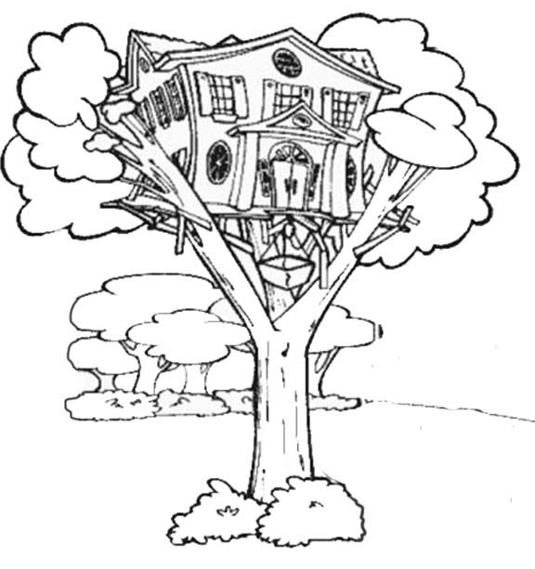
This next part of the project is an individual activity.

Create a thorough list of the steps one takes to complete finite element analysis of the stress, strain, deflections, and reaction forces in/on a 1D bar structure. I am not looking for complete sentences in this exercise; instead, I am looking for clear instructions, including relevant equations in pseudo code language where applicable. We will discuss what I mean by “pseudo code” in class and I will post an example on Course Site.

For this part of the project, you are not really thinking about Aunt Ada and her epic tree house. What I am looking for here is an algorithm description for a computer code that solves a 1D FEM problem. That is why you are encouraged to cast your instruction list in terms of equations and, where possible, pseudo code. You will see in class (and from my example) that it may be easier to write pseudo code by hand, rather than with a word processor. If you submit hand written work, please be sure it is neat and clear enough to be fully legible.

If you think about Quiz #2, the instructions for that sort of laid out the steps to solving a 1D FEM problem; however, your algorithm description, or flowchart, should be complete and it should indicate how to get the stress and strain in every element as well as the reaction forces. Obviously, before you do that, you have to solve for unknown nodal displacements. But, before you do that, you have to set up the reduced, global K matrix, as well as the reduced U and F vectors. And before you do that, you have to … etc, etc.

You should start at the very beginning: what must be defined and what rules apply for governing that information? For example, we know that a node must be defined at each end of the entire 1D bar structure; furthermore, a node must exist wherever an external force is applied. Similarly, a node must exist at any point where the area or Young’s modulus changes discontinuously. We may decide that, for accuracy, we need more nodes (i.e. more elements) but there are rules governing the minimum number of nodes/elements. Once all necessary starting information is defined, describe each step that must be taken to proceed from defining the problem to completing the analysis of the problem. Also, as already discussed, you should use words in your flowchart (or algorithm description) but lean heavily toward equations and pseudo code. You should assume that the bar structure can only be fixed to a wall at one or both of its ends and nowhere between.

